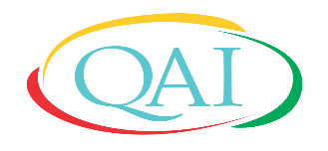
Change Adapt Improve
Quality and Accreditation Institute
Centre for Education & Training
Quality Management System and Internal Auditor Training Course as per ISO/IEC 17025:2017

Registration Form
Date: 21 – 27 September 2020 (3 hours On-line evening classes for one week) |  | Photo
Venue: QAI Secretariat (Virtual Platform)

Name Dr/Mr/Ms [in Capital letters)_________________________________________
Designation_____________________________________________________________
Name and Address of Organisation_________________________________________________
_______________________________________________________________________
Mobile_______________________________Email_________________________________

(Signature of the Participant)

Course Fee: Rs. 6000 + GST@18% i.e Rs.1080 (Total fee Rs. 7080)
Candidates are requested to pay the fee after confirmation mail.
Completed form may please be sent to rehma@qai.org.in

Bank Transfer details are:
Beneficiary name: Quality and Accreditation Institute Pvt. Ltd.
Bank Account number: 003105031612
Bank Details: ICICI Bank Limited, K-1, Senior Mall, Sector 18, Noida-201301
Bank IFSC Code: ICIC0000031

