QAI CLA 112

Quality and Accreditation Institute
Centre for Laboratory Accreditation

Change Adapt Improve

APPLICATION FORM
FOR
QAI RECOGNITION FOR
MEDICAL LABORATORIES
(BASIC/MEDIUM/ADVANCE)

Issue No. : 03 | Issue Date : January 2021

CHANGE HISTORY

Sl. No. | Doc. No. | Current Issue No. | Revised Issue No. | Date of Issue | Reasons
1 | CLA 112 | 01  Nov. 2018 | 02 | May 2019  (10 May 2019) | Fee structure modified  ‘Declaration by laboratory’ modified to include certain terms and conditions.
2 | CLA 112 | 02 | 03 | January 2021  (28 January 2021) | Certification term changed to Recognition, QCBCML changed to QRML, type of laboratory and Fee structure added
3
4
5

FEE STRUCTURE

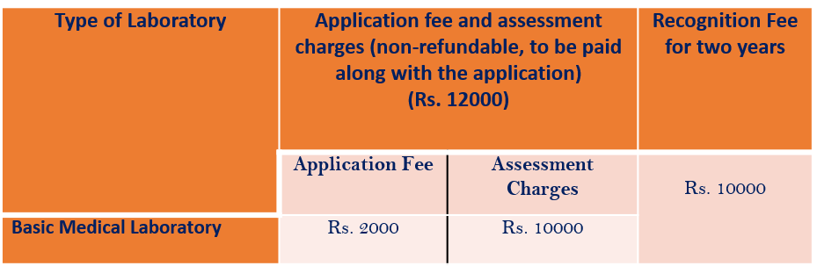
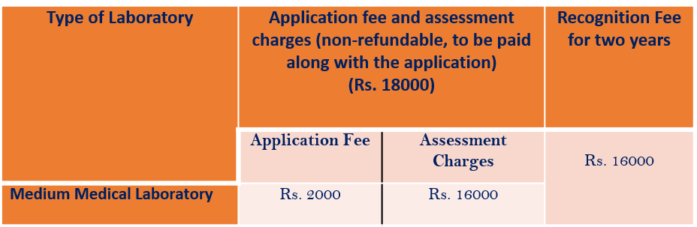
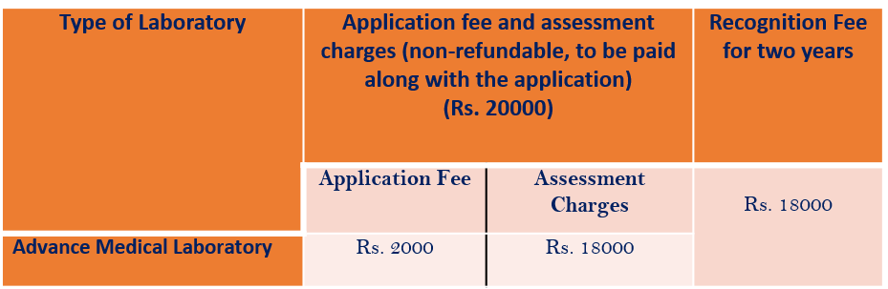

In addition to the above-mentioned fee, GST @18.0 % or as applicable from time to time to be
paid.

CONTENTS

Sl. No. | Title | Page No.
1 | Information & Instructions for completing an Application Form | 4
2 | Application Form | 5

Information & Instructions for Completing an Application Form

- A laboratory performing the tests covered under QAI Recognition Programme for Medical Laboratories Basic/Medium and Advance in Gazette notification G.S.R. 468(E) dated 18th May, 2018 and related amendment dated 14 February 2020 by MOHFW to amend Clinical Establishments (Central Government) Rules, 2012 is eligible to apply under this programme.

- Application shall be made in the prescribed form QAI CLA 112 only. Applicant laboratory is requested to submit the following:
- Soft copy of completed application form
- Soft copy of standard tool
- Prescribed application fees
- Soft copy of signed QAI CLA 115 ‘Terms and Conditions for Obtaining and Maintaining
Recognition for Medical Laboratories’
- Application form and standard tool can be downloaded from website www.qai.org.in. Incomplete application may lead to delay in processing of your application.
- The applicant laboratory shall provide soft copy of appropriate document(s) in support of the information being provided in this application form.
- Laboratory is advised to familiarise itself with QAI CLA 111 ‘Information Brochure of QAI Recognition for Medical Laboratories- Basic/Medium/ Advance’ (QRML).
- The applicant laboratory shall intimate QAI CLA about any change in the information provided in this application such as scope applied for recognition, personnel and location etc. within 15 days from the date of changes.

Application Form of QAI Recognition for Medical Laboratories (Basic/Medium/ Advance)

- We apply for QAI CLA Recognition for Medical Laboratory as per details given below:

 | First Recognition |  |  |  | Renewal of Recognition

- Choose the type of medical laboratory
- Basic
- Medium
- Advance

- Laboratory Details
3.1 | Name of the Laboratory _________________________________________
Complete Address(s)___________________________________________
_____________________________________________
Telephone No. _____________________ E-mail ________________

3.2 | Do you conduct Testing in the following Category
 | (if yes, please clearly indicate in the scope of recognition, sl. no. 2.1, the test conducted)
 | a. | Site Facility (when undertaking testing at site of the customer) |  | Yes/No
 | b. | Permanent Facility |  | Yes/No
 | c. | Mobile Laboratory |  | Yes/No

3.3 Name of the Parent Organisation ______________________________
(if laboratory is a part of a bigger organisation)
Telephone No. _____________________ E-mail _______________

3.4 Goods and Service Tax (GST) No. ______________________________

3.5 Legal identity of the laboratory and date of establishment _________________
(Please give registration number and name of authority who granted the registration. Copy of the certificate shall be enclosed)

3.6 Type of laboratory by service
Open to others Yes/No
Partly open to others Yes/No
An in-house activity Yes/No

3.7 Other certification(s)______________________________________________

- Details of Recognition Sought

4.1 Scope of Recognition

Discipline: Biochemistry

Sl. No. | Type of Samples examined/ Tested | Specific tests/ examination performed | Standard (method), Principle /Methodology or Technique used

Discipline: Haematology

Sl. No. | Type of Samples examined/tested | Specific tests/ examination performed | Standard (method), Principle /Methodology or Technique used

Discipline: Histopathology

Sl. No. | Type of Samples examined/tested | Specific tests/ examination performed | Standard (method), Principle /Methodology or Technique used

Discipline: Molecular Genetics

Sl. No. | Type of Samples examined/tested | Specific tests/ examination performed | Standard (method), Principle /Methodology or Technique used

Discipline: Cytopathology

Sl. No. | Type of Samples examined/tested | Specific tests/ examination performed | Standard (method), Principle /Methodology or Technique used

Discipline: Immunohistopathology

Sl. No. | Type of Samples examined/tested | Specific tests/ examination performed | Standard (method), Principle /Methodology or Technique used

Discipline: Medical Microbiology & Immunology

Sl. No. | Type of Samples examined/ tested | Specific tests/ examination performed | Standard (method), Principle /Methodology or Technique used

- Organisation

  - Senior Management (Name, Designation, Telephone, E-mail)

    - Chief Executive/ Director/ Head of the laboratory _____________________

    - Contact person for QAI-CLA _____________________________________

  - Human Resources

    - Details of staff

Sl. No. | Name | Designation⁺ | Academic and Professional Qualifications* | Experience related to present work (in years)

- Equipment and Reference Materials:

List of major test equipment available for use:

Sl. No. | Name of equipment | Model/ type/ year of make | Receipt date & date placed in service | Date of last calibration | Calibration  due on | Calibrated by

List of reference materials available for use:

Sl. No. | Name of reference material/ strain/ culture | Source | Date of expiry/ validity | Traceability

- Proficiency Testing

Participation in PT / EQAS/ any other Inter Laboratory Comparison

Sl. No. | Product/ Material | Details of Test(s)/ examination | Date of Testing/ examination | Organizing body | Performance in terms of z score or any other criteria | Corrective action taken (if required)

- Application Fees

  - Application fees (INR).___________________________________________

  - DD/At par cheque number/ bank transfer reference number_____________
________________________________________________________________

- Declaration by the laboratory

We declare that:

  - We are familiar with the terms and conditions of maintaining recognition as described below in this application form (sl. no. 7.2 to 7.8). We also undertake to abide by them.

  - We agree to comply fully with the requirements of QAI Recognition for Medical Laboratories (Basic/Medium/ Advance)

  - We agree to comply with recognition procedures and pay all costs for any assessment carried out irrespective of the result.

  - We agree to co-operate with the assessment team appointed by QAI CLA for examination of all relevant documents by them and their visits to those parts of the laboratory that are part of the scope of recognition

  - No adverse action has been initiated / taken against the laboratory in the past. (If yes, please provide the details with present status ………………………………………………………..)

  - All information provided in this application is true to the best of our knowledge and ability.

Signature of CEO/Laboratory Head/ Laboratory Director ___________________

Name & Designation _______________________________________________

Date & Place _____________________________________________________

Quality and Accreditation Institute
Centre for Laboratory Accreditation
Website: www.qai.org.in
Twitter@QAI2017

